**Capstone Project - The Battle of Neighborhoods (Week 2)**

**Introduction/Business Problem**

**A description of the problem and a discussion of the background.**

My Business Partner and I wish to open an Italian Restaurant in Toronto.

The plan is to find an area which combines the following:

* An area people eat out in
* An area with a lower number of Italian Restaurants near by

**A description of the data and how it will be used to solve the problem.**

I will use the Toronto data collected in the Wk 3 assignment that included the foursquare data so that I can analyse the area.

What I shall look for:

* I will look for busier areas which are full of various establishments
* I will look for areas with high numbers of places to eat and drink (restaurants, pubs and cafes)
* I will check there no / very few Italian restaurants in these areas.

**Methodology**

Using the Foursquare data it can be seen that there are a lot of neighborhoods in Toronto. This is obviously too many to easily pick an area in which to open a restaurant. Therefore it is necessary to delve a little deeper.

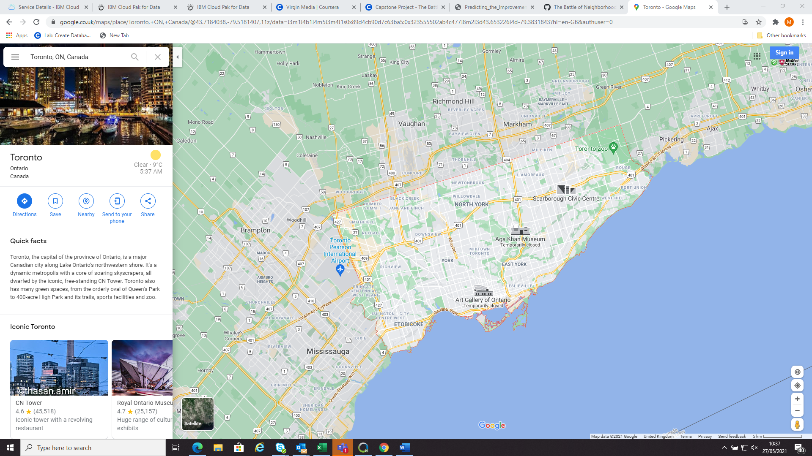

The first step to breaking down the data was to see which areas were the busiest in terms of venues in the neighborhood.

The Foursquare data had a maximum venues by neighborhood of 30. These areas would be chosen as they would have the most footfall.

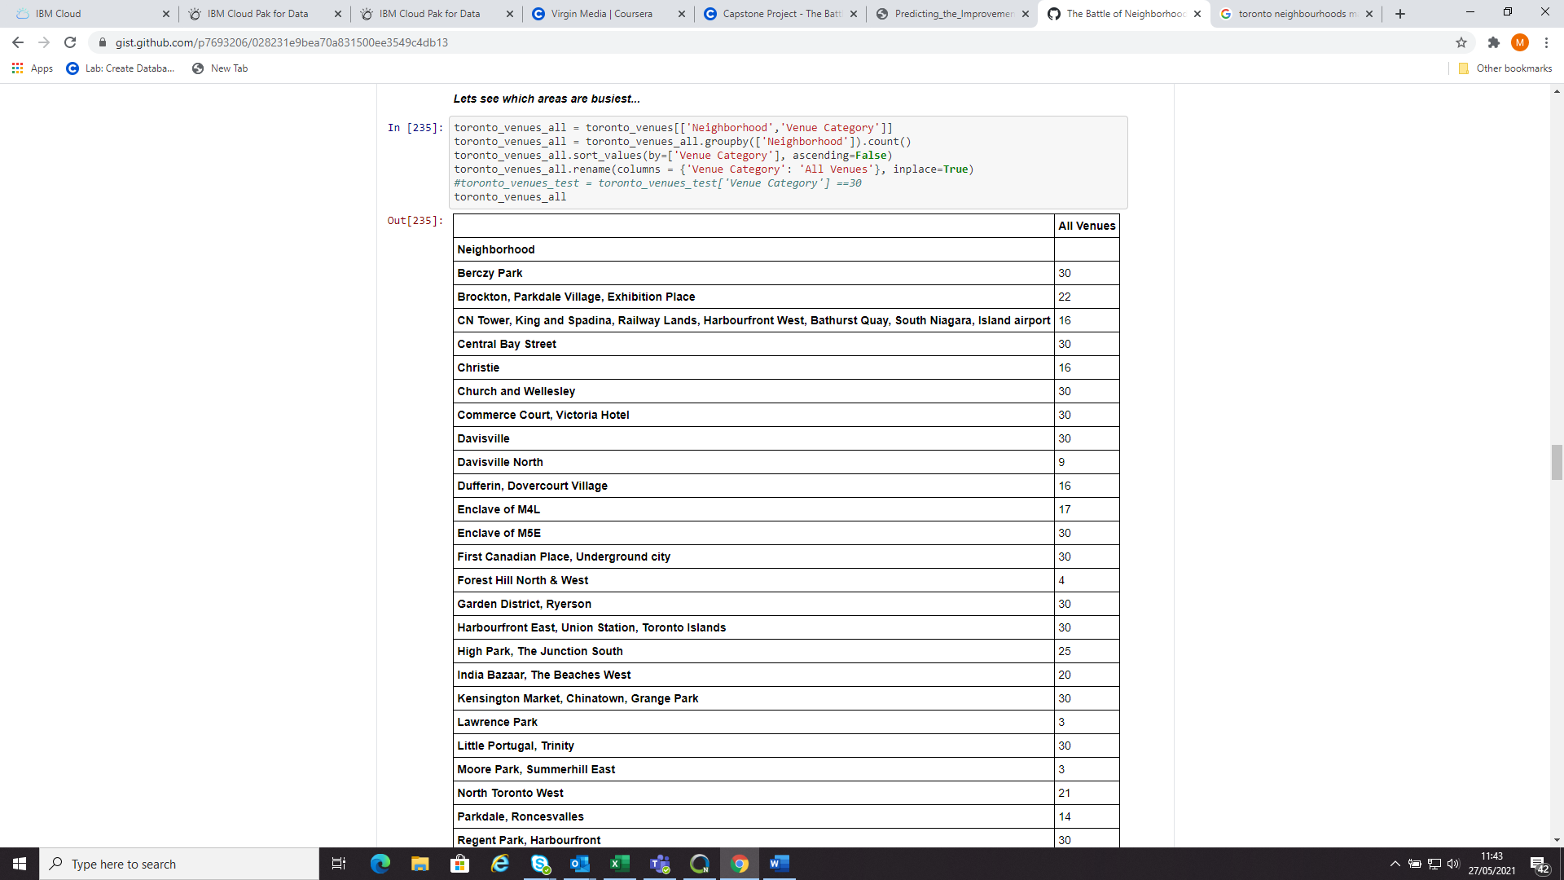

Then we need to see which of the busiest Neighborhoods were also popular for eating out. There were 197 different venue categories within the data so the data was grouped using the code below:

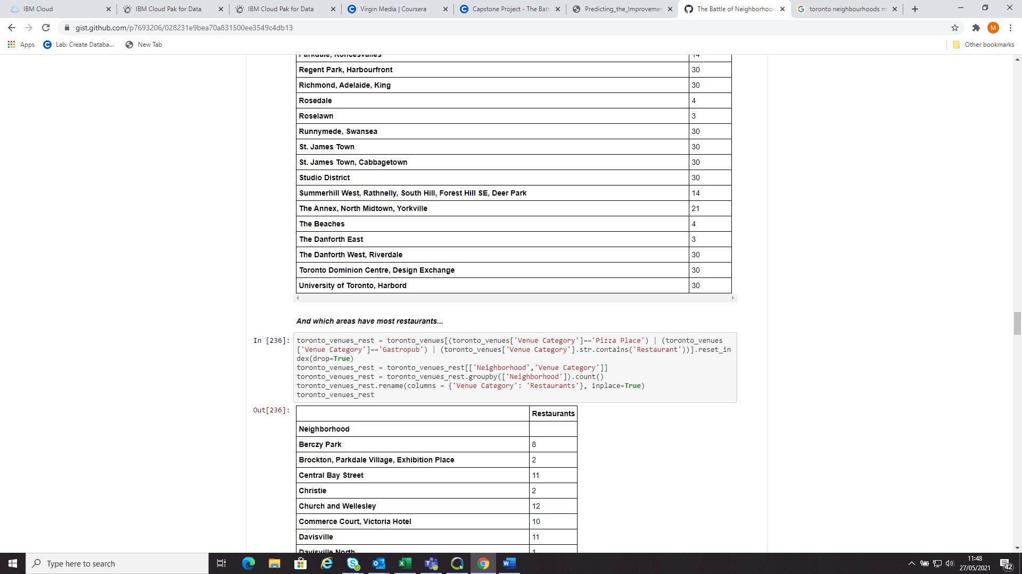

Then we combined the data to see how many eateries there were in the busier areas

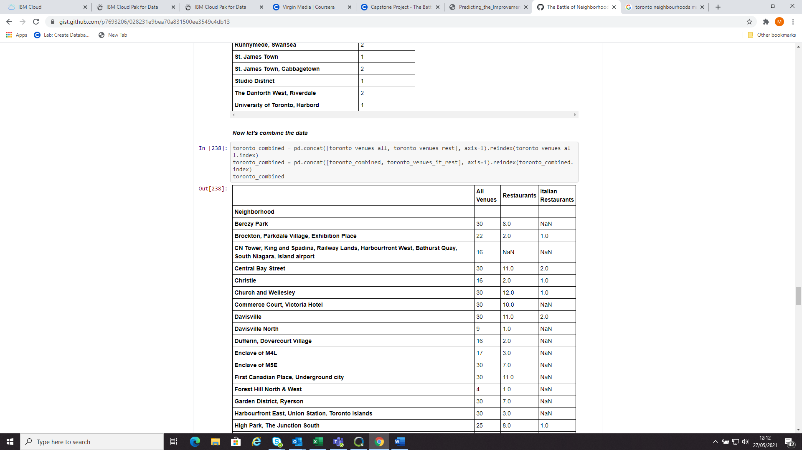

From this dataset set we can start to produce our results.

**Results**

This isn’t easy to see which areas would be best to open an Italian restaurant in from this data so transferred the data into the graph below:

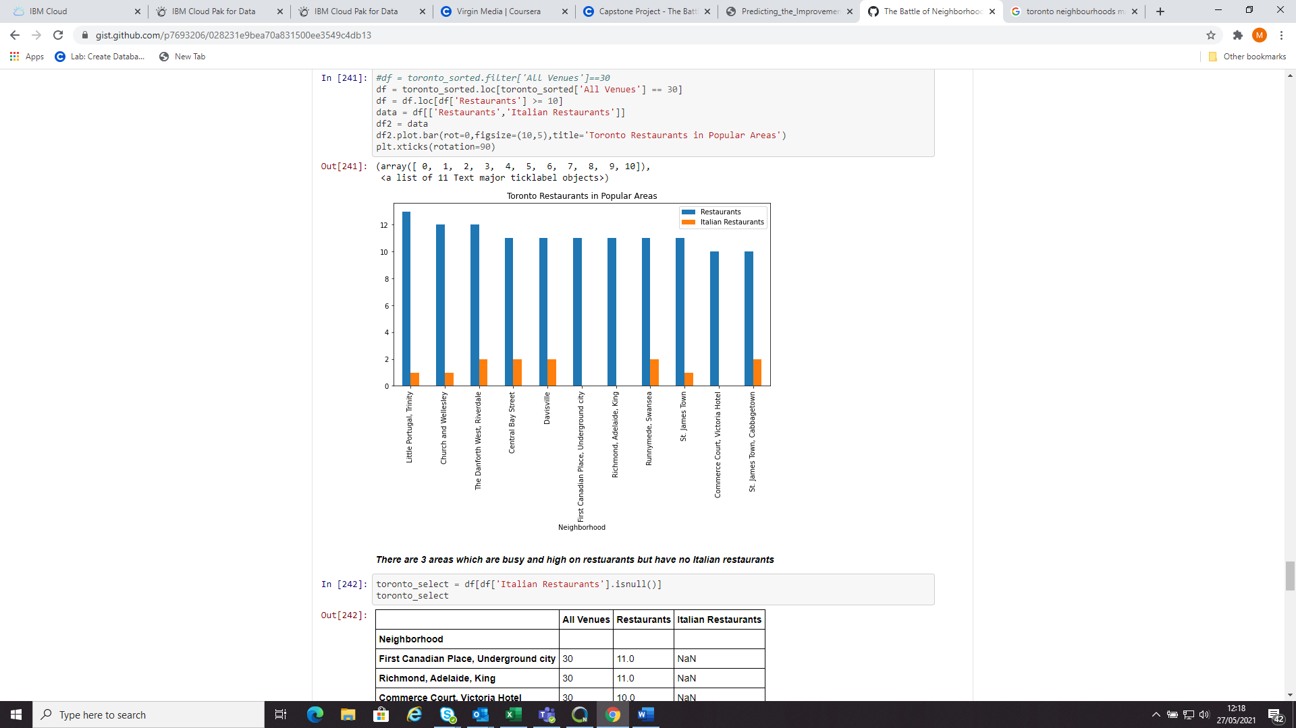

From the graph it can be seen that there are 3 neighborhoods in popular areas in terms of both of a high number of venues and high number of eateries but with no Italian restaurants. Those areas are:

* First Canadian Place
* Richmond, Adelaide, King
* Commerce Court, Victoria Hotel

We will focus on these neighborhoods.

Using the Foursquare data we can see what is also in those neighbourhoods:

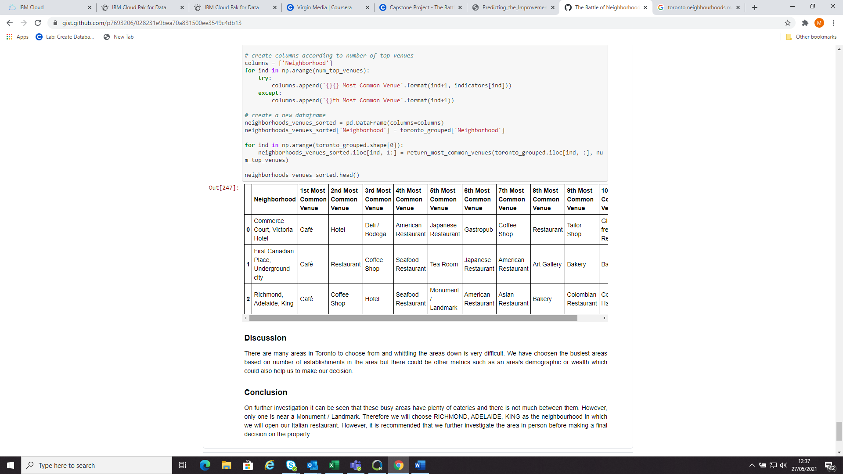

And where they are on a map…

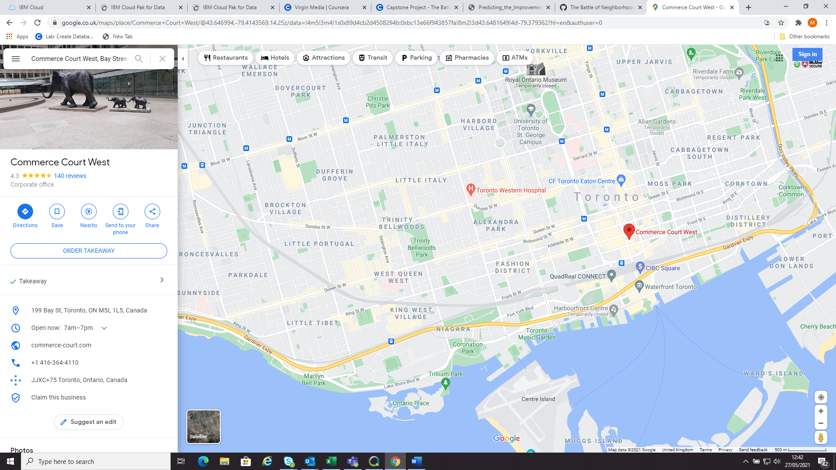

**First Canadian Place**

**Richmond**

**Discussion**

There are many areas in Toronto to choose from and whittling the areas down is very difficult. We have chosen the busiest areas based on number of establishments in the area but there could be other metrics such as an area's demographic or wealth which could also help us to make our decision. A further factor would be the cost to rent a suitability sized restaurant in such a popular area.

**Conclusion**

On further investigation these busy areas have plenty of eateries and there is not much between them. However, as Richmond is in the Fashion District. Therefore we will choose RICHMOND, ADELAIDE, KING as the neighbourhood in which we will open our Italian restaurant. However, it is recommended that we further investigate the area in person before making a final decision on the property.